Highcliffe School Student Bulletin

Monday 16th – Friday 20th July 2007: Week B

Thought For The Week:
Courage is being scared to death - but saddling up anyway.
John Wayne


Activities Week:
The full programme for Activities Week is attached to this bulletin. Please make sure you know what you are doing on each day (there are lists in tutor rooms & on the board outside the Data & Exams office).
A few general points:
- All students are to register in their tutor rooms as usual every morning.
- Full school uniform is to be worn each day unless you are instructed otherwise.
Have an enjoyable and interesting week!

Final payment for Osmington Bay was due in Friday 13th. If anyone still has an outstanding payment, please could this be handed in to finance before the summer break.

Hengistbury Head Outdoor Activities Day: If you are being taken to Hengistbury Head from school, please wait outside the main reception area straight after registration. We will be leaving at 8.45am. Miss Martindale

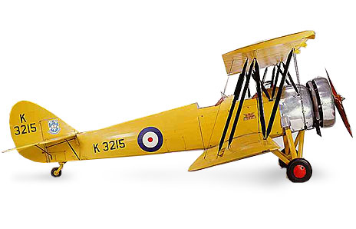
Fleet Air Arm Museum Trip (Year 8 and Year 9 students) Tuesday 17th July:
We will depart at 8 am so please make sure you arrive on time as we shall be unable to wait for latecomers. Students must bring a packed lunch and wear school uniform. They may wear trainers. We shall return to school at 6.00pm so please ensure someone is at school to pick you up.
Any problems see Mrs Barclay.

Year 9 GCSE History: If you have chosen to do GCSE History next year you must get your Revision Book money in by Wednesday at the latest.

Year 7 "All Abroad!" trip to St Omer - Wednesday 18th July:
All medical consent forms should have been in last week. A reminder that you can't travel without a form. All students getting on at Highcliffe to meet at 5.00am.We can't wait for late arrivals.

Year 9 students may come to school in their PE kit for the Alternative Sports Day. Normal PE kit only.
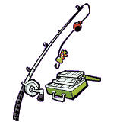
Fishing Magazines: There is now a selection of Fishing Magazines that can be taken out of the Library, to read over the summer holidays. If you are interested, please come and see Mrs Wheeler in the Library.

A reminder to all students to remove anything from the top of your lockers or it will be disposed of during the holidays

SUPER FACTS:
- The top speed of a British grass snake is 4.2mph.

